APPENDIX A
PHOTOGRAPHS TAKEN DURING JIV AT 18” TEBIDABA-BRASS PIPELINE AT KAMBORO COMMUNITY, SOUTHERN IJAW L.G.A, BAYELSA STATE ON 15TH MARCH, 2024.
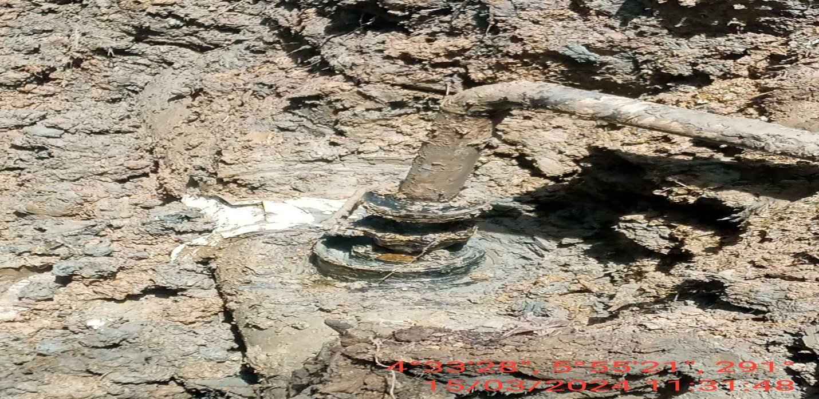
Fig.1: 4” valve re-installed at 12 o’ clock position of the pipeline by unknown person(s)
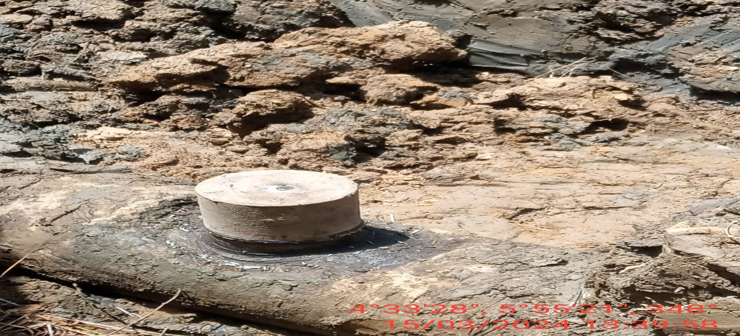
Fig. 2: The incident point after repair has been carried out.

